**23rd Annual Oceanside Dia de los Muertos**

**Dia De Los Muertos Car Show Application**

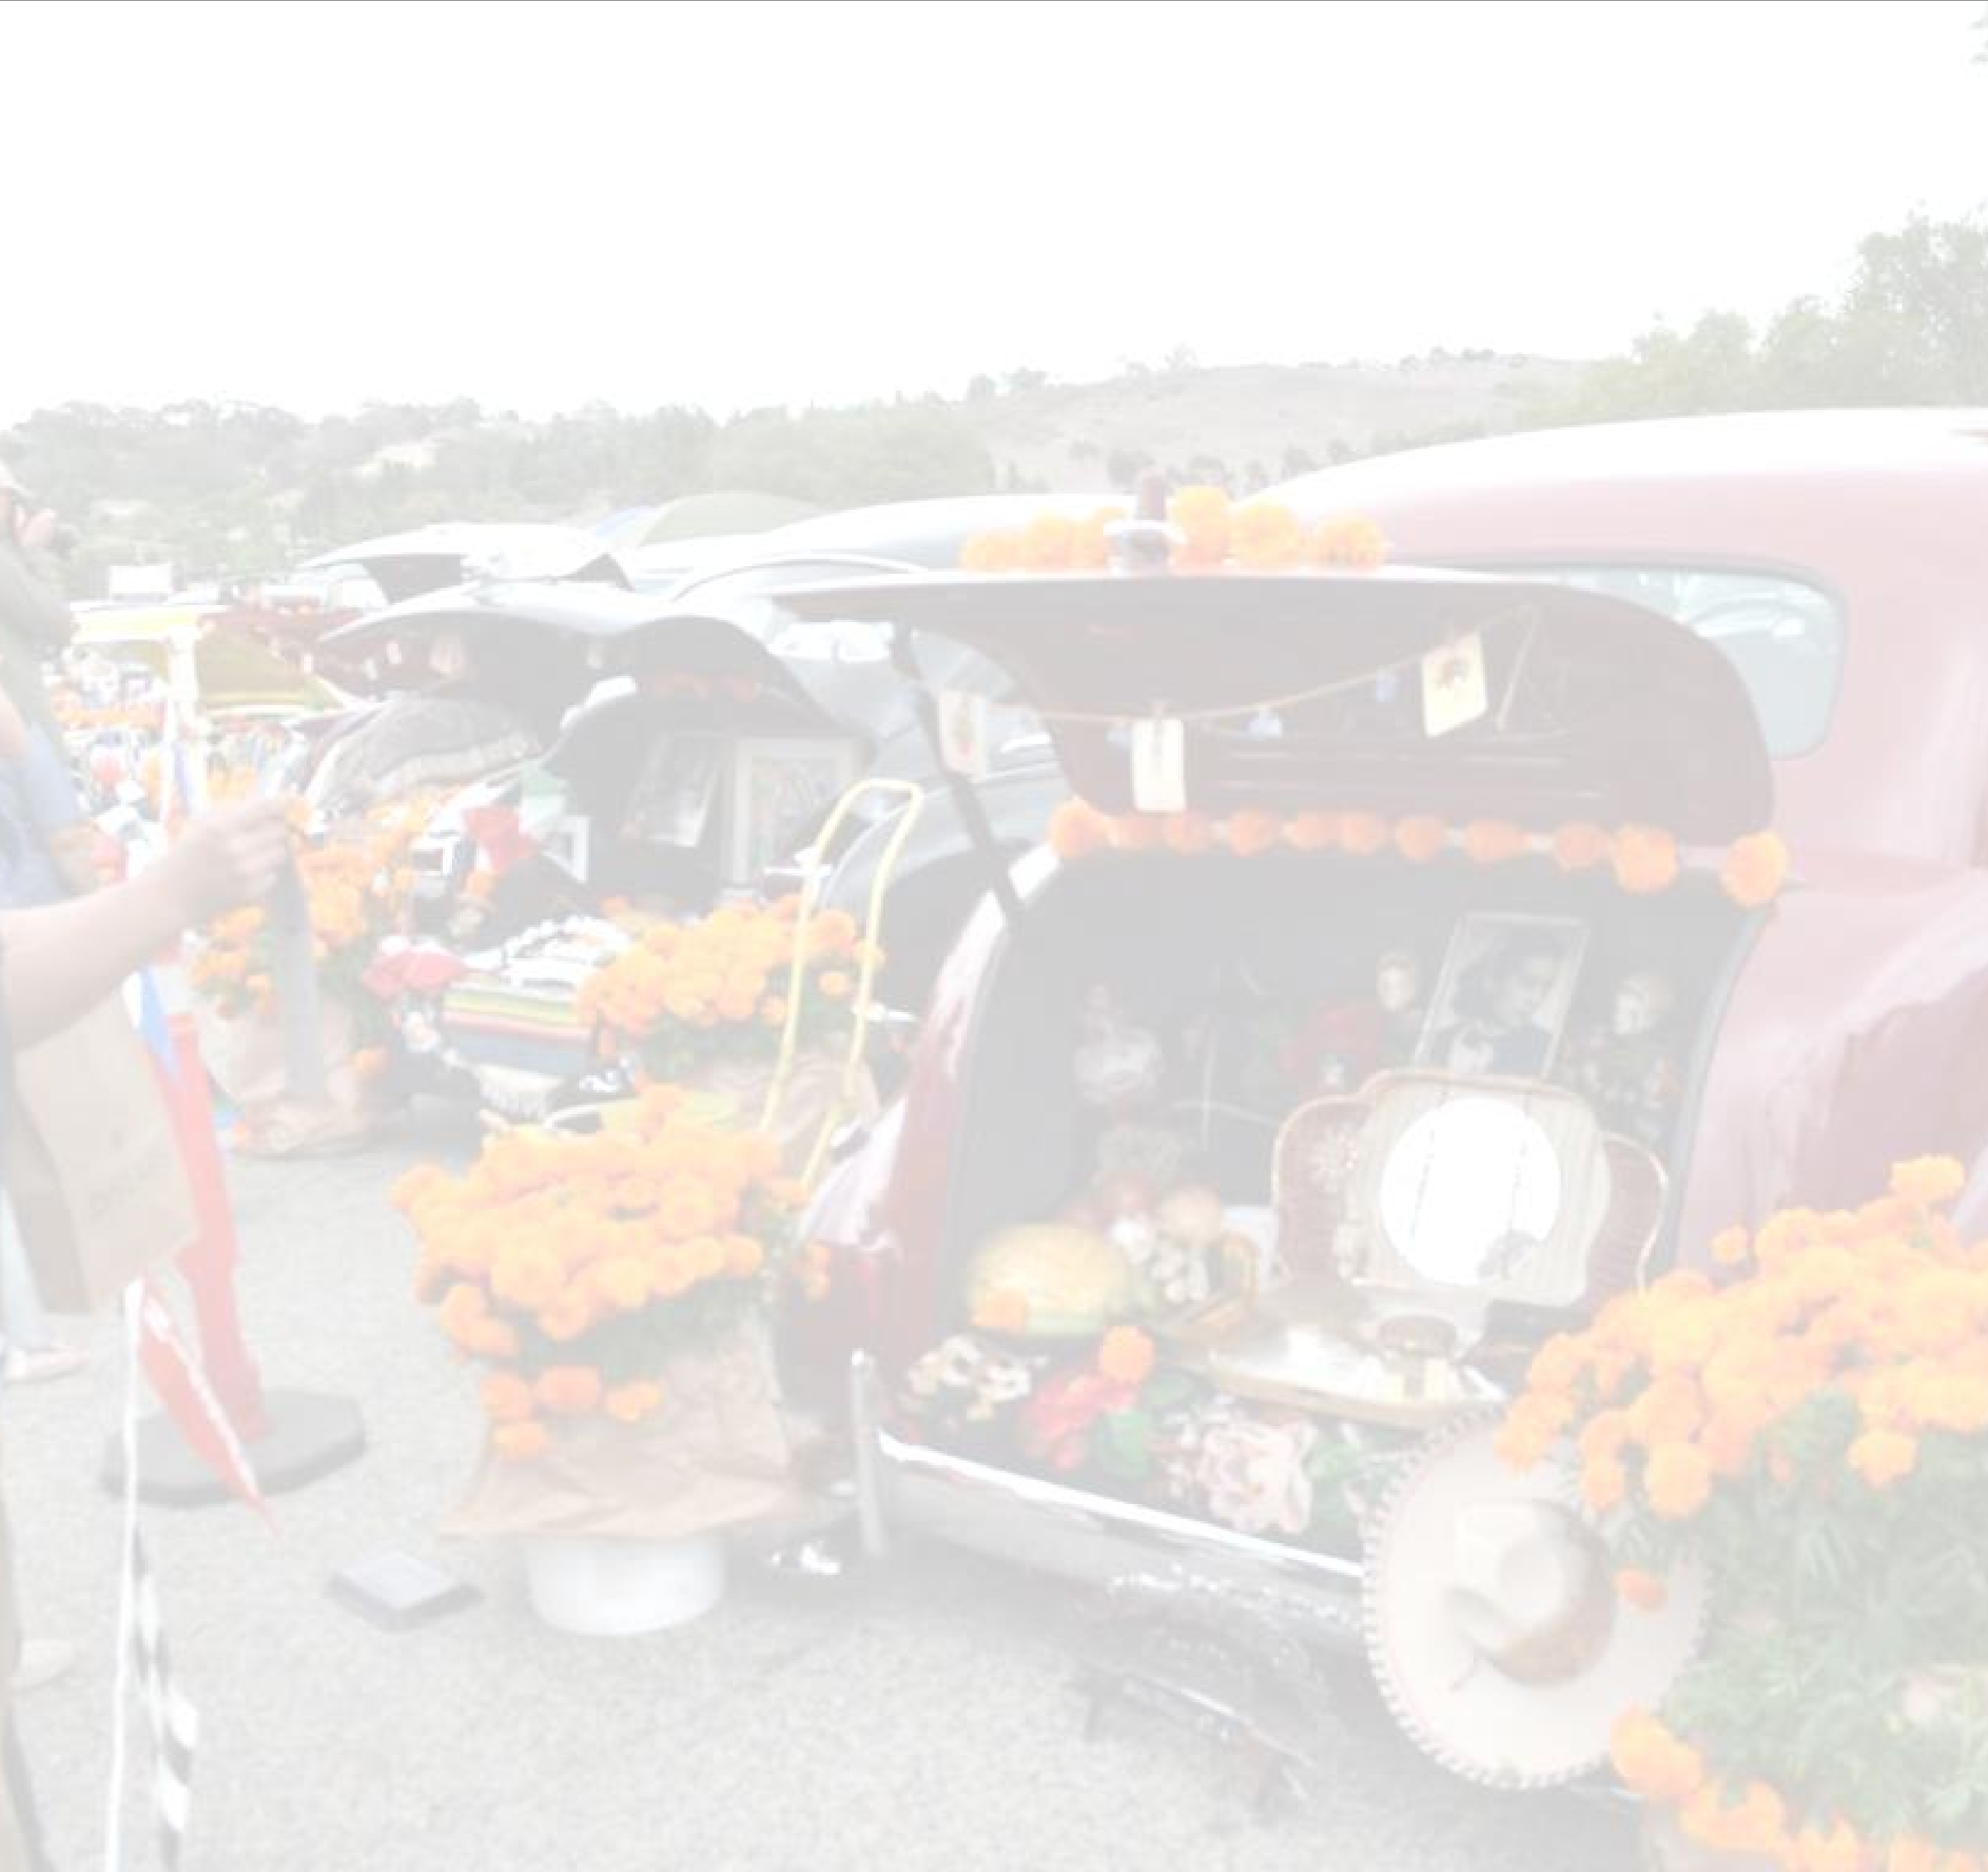

**Hosted by:**

# Sunday, October 27th, 2024

**At:** *Downtown Oceanside* **Hours:** 10AM to 5PM

**Featuring:** Arts & Crafts, Chalk Cemetery, Altars, Food, Kids Activities, Traditional Dancers, Entertainment, Festival Experience and Education

Name: _______________________________________________ Cell: ____________________

Address: ________________________________________________ City: _________________ Zip: __________

Email: ______________________________________________________________________________________

Make: _________________________ Model: __________________________________ Year: ______________

Additional Info: _______________________________________________________________________________

**Fees per vehicle for the event (cash/check): $30**

Make checks payable to Friends of Oceanside Dia de los Muertos.

**Altars are an important part of the Dia de los Muertos celebration (not required but highly encouraged)**

**NO ONLINE OR PRE-REGISTRATION THIS YEAR!!**

**ALL APPLICATIONS WILL BE GIVEN TO THE POR SIEMPRE CAR CLUB (CEDMA & MANUEL NAVARRO)**

**PROHIBITED:** **NO substitions for entries.**

**Alcohol is strictly PROHIBITED at Dia de los Muertos! No hitting the switches, No BBQ’s, No gun or drug paraphernalia!**

**$30 registration day of event, first come first serve**

**Read and Sign Below:**

I agree to indemnify, defend, waive, release, and Friends of Oceanside Dia de los Muertos, Por Siempre Car Club, the City of Oceanside, its officers, agents, volunteers and/or employees harmless from any and all liability, claims, and causes of action for injuries to person or property arising out of or related to Dia de los Muertos, specifically including, without limitation, injury and damage to booth and contents, merchandise, employees, contractors, guests, customers, invitees, and all other third parties.

The undersigned gives permission to the Friends of Oceanside Dia de los Muertos and Por Siempre Car Club for the use of any photographs supplied by the Exhibitor, for any information related to Exhibitor’s vehicle and to use any photographs taken at the event. I also agree I will not bring nor consume alcoholic beverages while on the premises of the Friends of Oceanside Dia de los Muertos Festival Area.

Print Name: _________________________ Signature:____________________________ Date: _____________ **APPLICATIONS INFORMATION:** Por Siempre Car Club, Attn: Chema or Manuel

**CELL: Manuel (760) 822-5407** **EMAIL: porsiemprecarclub@yahoo.com**

Questions about the car show or specifications can be directed to Chema (760) 305-2844

*WEBSITE:* [*www.friendsofoceansidediadelosmuertos.org*](http://www.friendsofoceansidediadelosmuertos.org)